# DATABASE PROJECT

## PART 1: DATA MODELING, CREATION AND BASIC QUERIES

## *ERD*

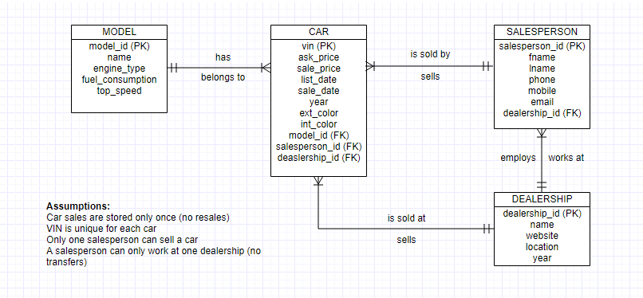

## *Data Dictionary*

|  |  |  |  |
| --- | --- | --- | --- |
| **MODEL** | | | |
| **Field** | **Data Type** | **Description** | **Example Data** |
| Model_ID (PK) | INT | The unique ID for each model (required) | 500 |
| name | VARCHAR | The name of the model | Huracan Coupe |
| engine_type | VARCHAR | The type of engine in the model | V8 |
| fuel_consumption | VARCHAR | Average fuel consumption of the model | 12.3 I/100 km |
| top_speed | VARCHAR | The top speed performance measure of the model | 324 km/h |

|  |  |  |  |
| --- | --- | --- | --- |
| **CAR** | | | |
| **Field** | **Data Type** | **Description** | **Example Data** |
| VIN (PK) | VARCHAR | The unique ID for each car (required) | SCBGE11RXBLA13261 |
| ask_price | DECIMAL | The retail price of car | 219800.00 |
| sale_price | DECIMAL | The price the car was sold at | 215000.00 |
| list_date | DATE | The date the car was put on market | 2017-01-01 |
| sale_date | DATE | The date the car was sold | 2017-01-01 |
| year | YEAR | The year the car was made | 2016 |
| ext_color | VARCHAR | The exterior color of the car | Havana |
| int_color | VARCHAR | The interior color of the car | Beluga |
| Model_ID (FK) | INT | The unique ID of the model of the car | 550 |
| Salesperson_ID (FK) | INT | The unique ID of the person who sold the car | 1 |
| Dealership_ID (FK) | INT | The unique ID of the dealership the car was sold from | 104 |

|  |  |  |  |
| --- | --- | --- | --- |
| **SALESPERSON** | | | |
| **Field** | **Data Type** | **Description** | **Example Data** |
| Salesperson_ID | INT | The unique ID of the salesperson | 1 |
| Fname | VARCHAR | The last name of the salesperson | Liu |
| Lname | VARCHAR | The first name of the salesperson | Allen |
| Phone | VARCHAR | Phone number of the salesperson | 85389865476 |
| Mobile | VARCHAR | Mobile number of the salesperson | 310 837 2039 |
| Email | VARCHAR | Email address of the salesperson | [aliu@lamborghini.com](mailto:aliu@lamborghini.com) |
| Dealership_ID | INT | The unique ID of the dealership the salesperson works for | 100 |

|  |  |  |  |
| --- | --- | --- | --- |
| **DEALERSHIP** | | | |
| **Field** | **Data Type** | **Description** | **Example Data** |
| Dealership_ID | INT | The unique ID of the dealership | 100 |
| Name | VARCHAR | Name of the dealership | Lamborghini Milano |
| Website | VARCHAR | The URL of the website | https://lamborghini-milano.com/it |
| Location | VARCHAR | The location of the dealership | Milano, Italy |
| Year | YEAR | Year the dealership was created | 1982 |

### *Database*

## Car

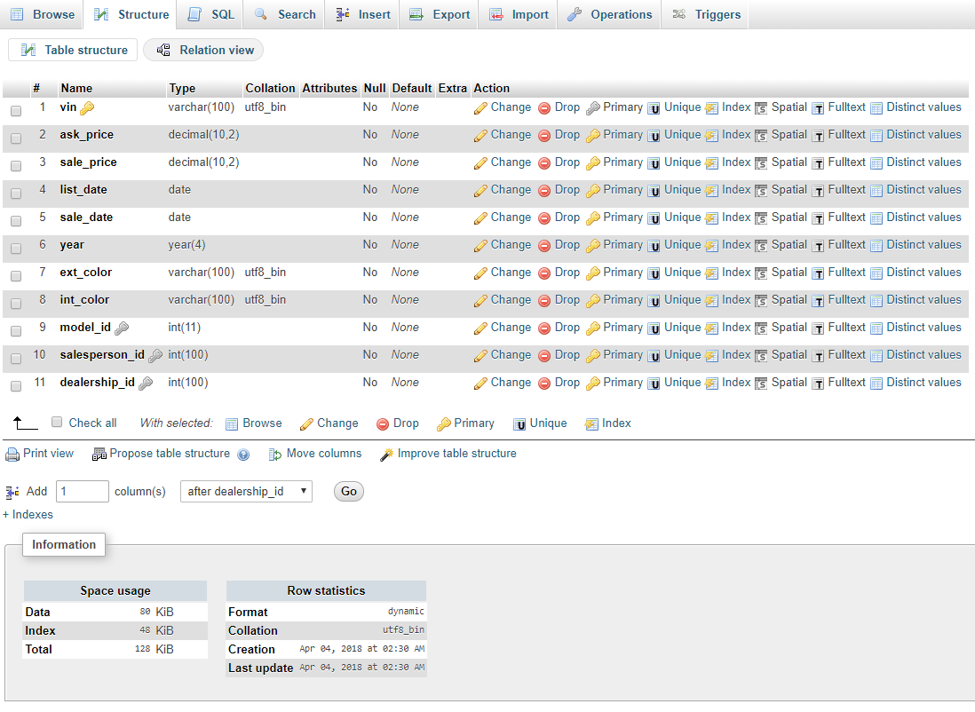

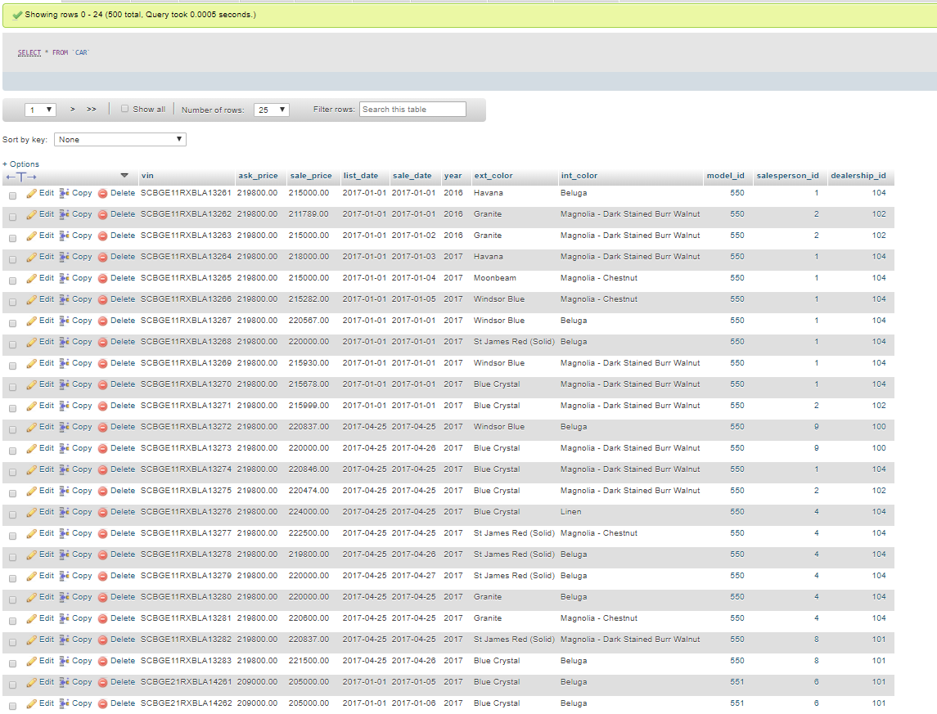

Salesperson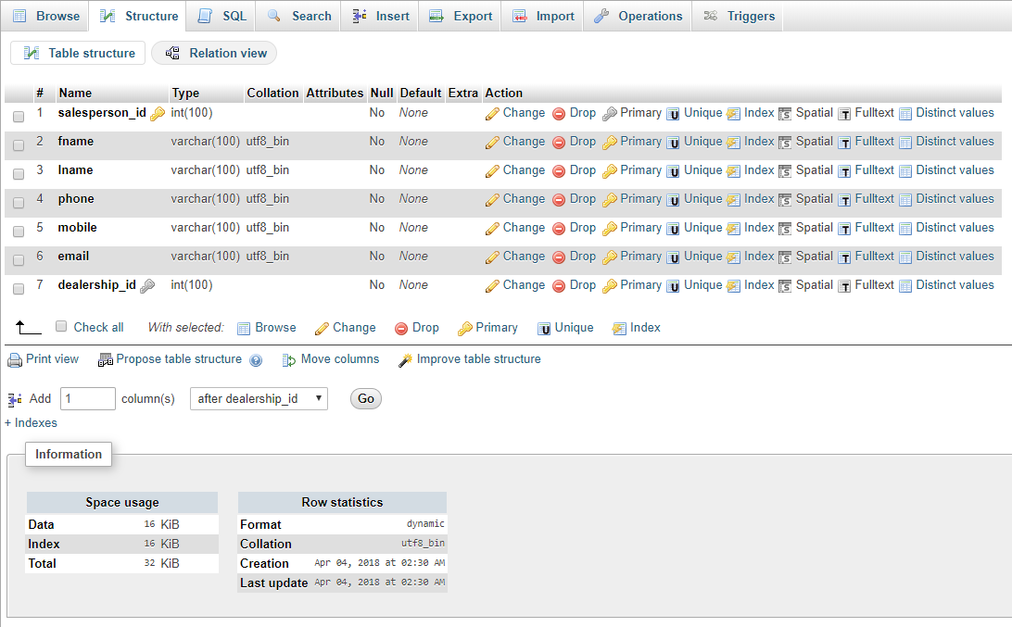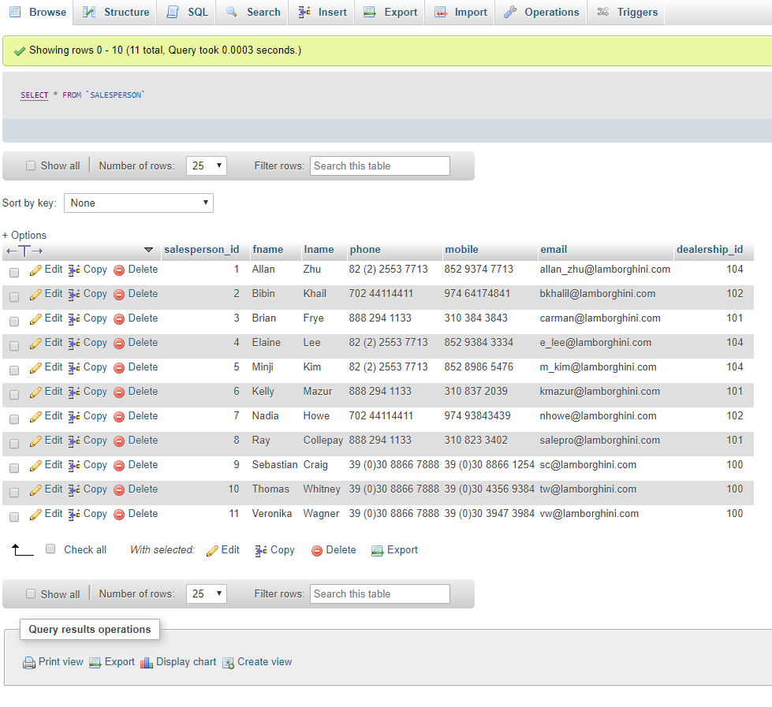

## Model

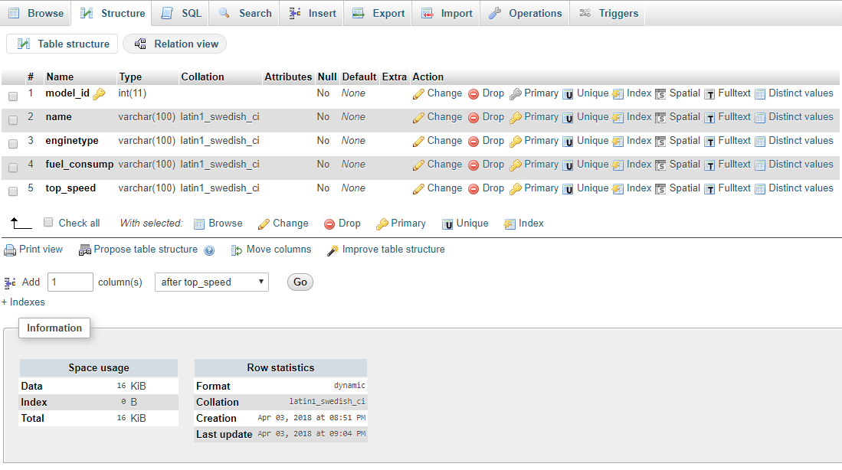

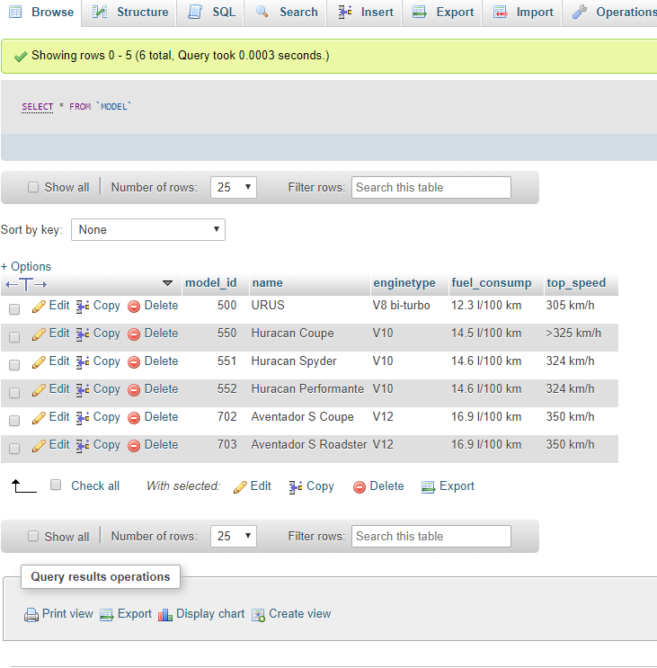

## Dealership

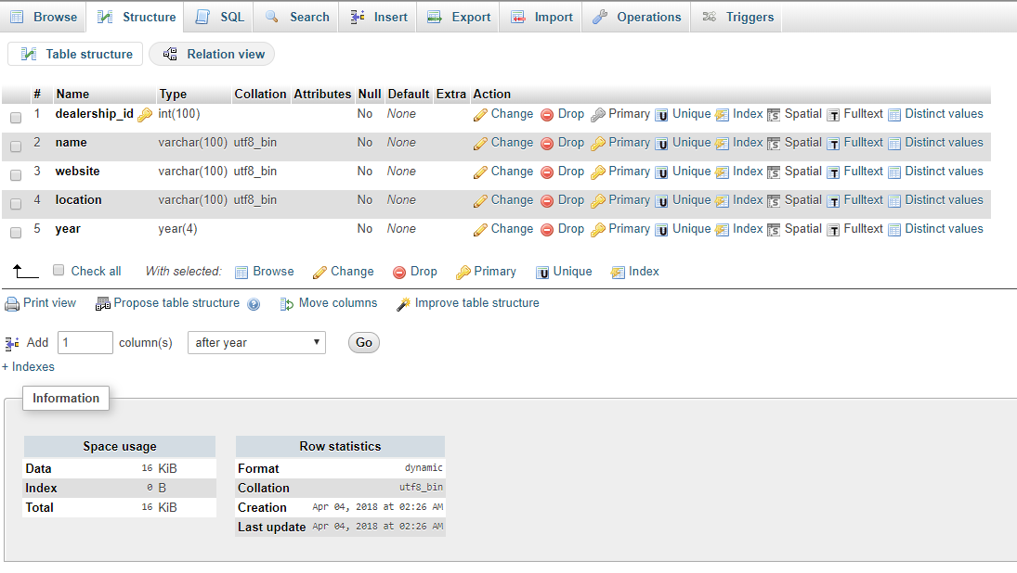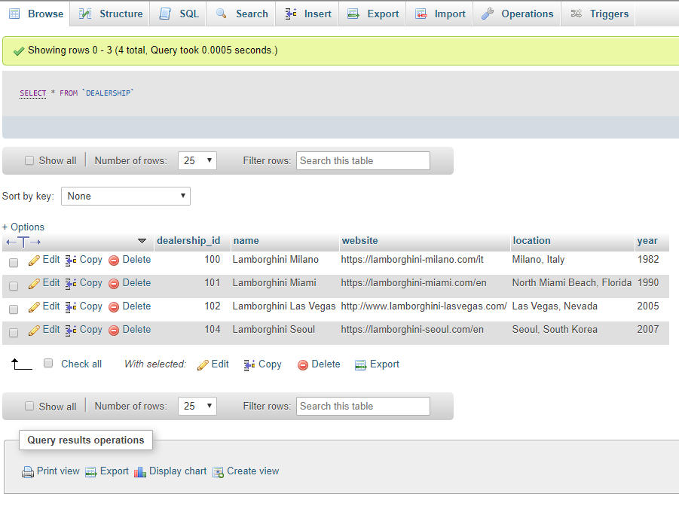

## PART 2: QUERIES

## Average Sales Price for All Vehicles

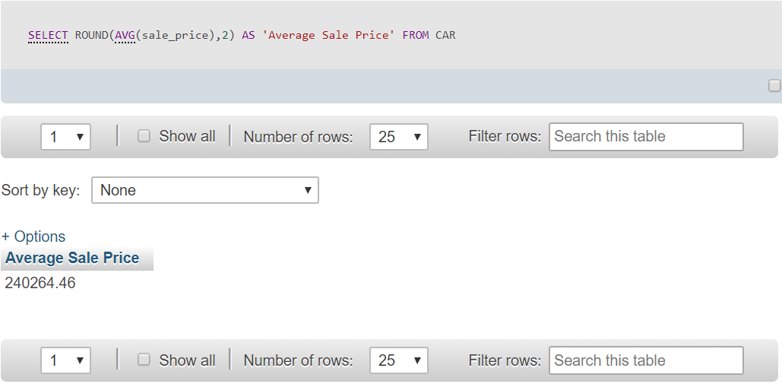

## Average Sales Price by Dealership

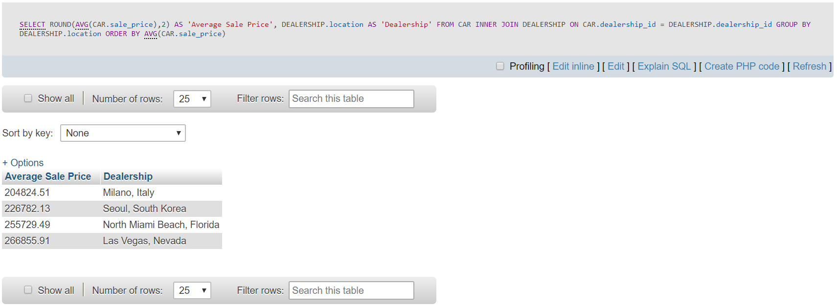

## Average difference in selling and asking price (sales price – ask price) by dealership

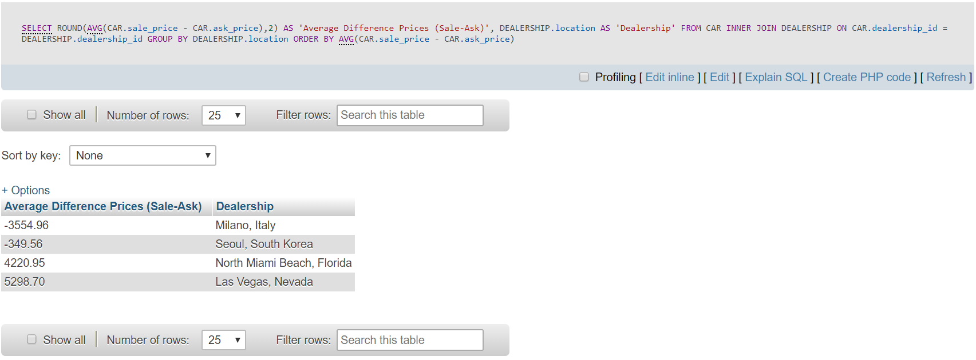

## Average time on the market by dealership

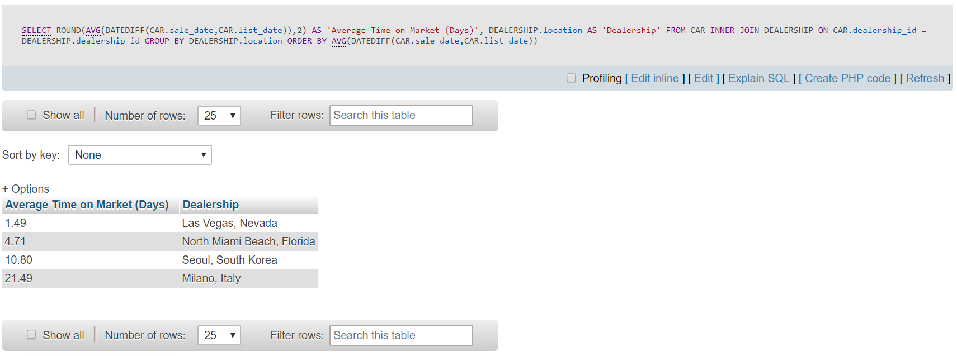

## Total number of cars sold by model for each dealership

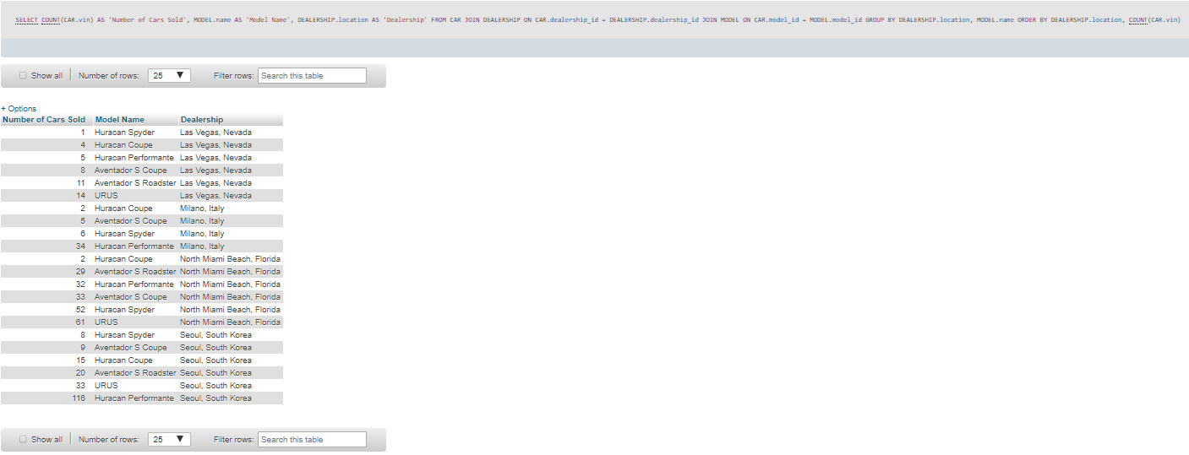

## Own Query: Total number of cars sold by each salespeople by dealership

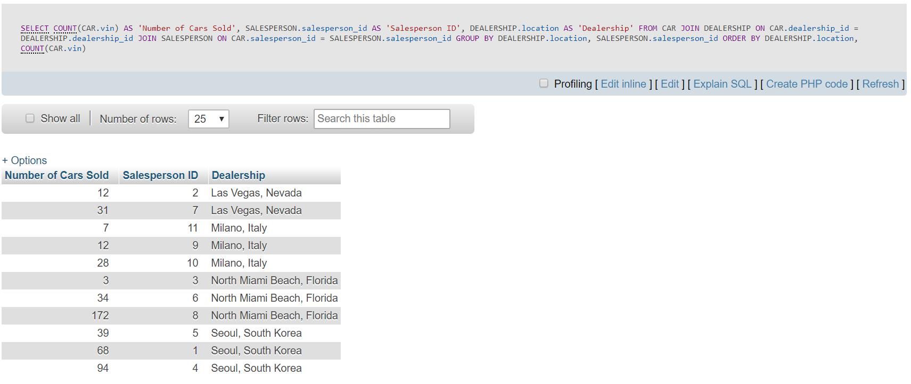

## PART C: BUSINESS MEMO

The dealership that deserves expansion is definitively the Las Vegas branch. They consistently are the best at nearly everything. The have the best average market time sold, best average difference between sales price and asking price. It also has the highest average sales prices on cars out of all the other branches, which is 266855.91 versus second that is 255729.41, helping them make the highest average profit.

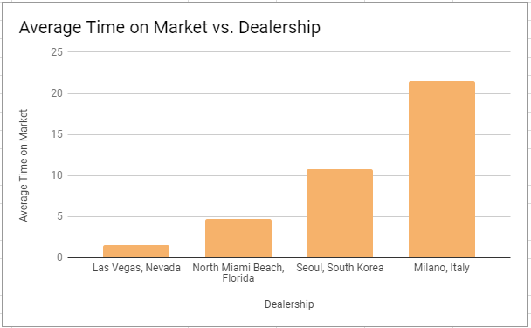

**Average Time on Market**

* *Las Vegas branch has the least amount of time per average on the market (1.49 days)* versus the next time that is North Miami Beach, Florida (4.71) which is a couple of days
* Las Vegas has the smallest time meaning that more cars can be sold faster maximizing profit
* Milano Italy takes by far more time than the other dealerships, taking 21.49 days.

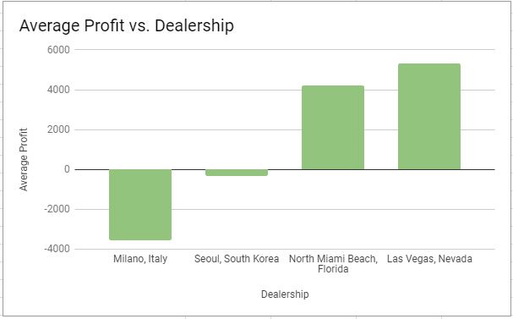

**The Average Profit by Dealership**

* Milano, Italy is losing a lot of profits and Seoul loses a little. However, Miami and Las Vegas are significantly making profit
* Las Vegas makes around 2000 dollars more in profits than Miami per average
* *Las Vegas has the highest Average Profit (Difference between Sales Price and Ask Price)*

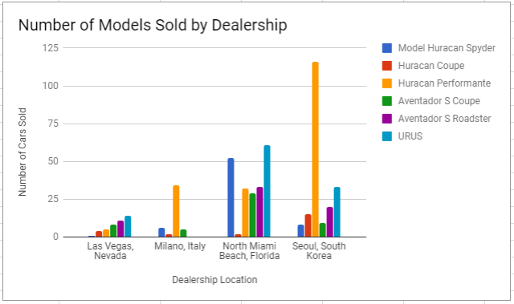

**The Number of Models Sold by Dealership**

* The number of Models Sold by Dealership tells us that *Las Vegas has a steady and a much closer proportion of sales of all the different cars that are sold* Miami sold a lot of one type of car and
* The rest had ones that they sold a lot and a bunch they sold much less

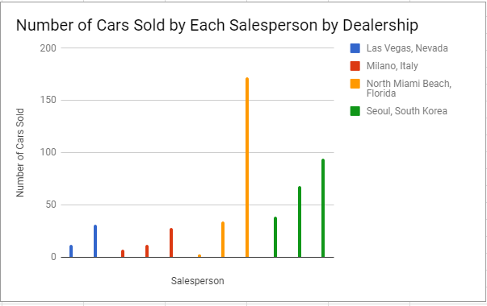**The Number of Cars Sold by Each Salesperson by Dealership**

* *Las Vegas has the least amount of salespeople (2 people vs. 3) and has around the same number of cars sold than Italy (Italy total sold 47 and Las Vegas sold 43) however they made the highest average profit*
* Sold around the same number of cars as Italy but the sellout times were much faster
* *Needs more people in Las Vegas, can make it more efficient especially since the dealership is doing so well already*

Some additional data that would be good to have to make an informed decision would be to know how long a dealership has been around so that the newer branches could expand more, and how long a salesperson has been at the dealership to gauge the amount of experience that the salespeople have. It would also be good to have some information how much it would cost to expand per square mile for each area.

## PART D: ADDITIONAL DATA CONSIDERATIONS

a. 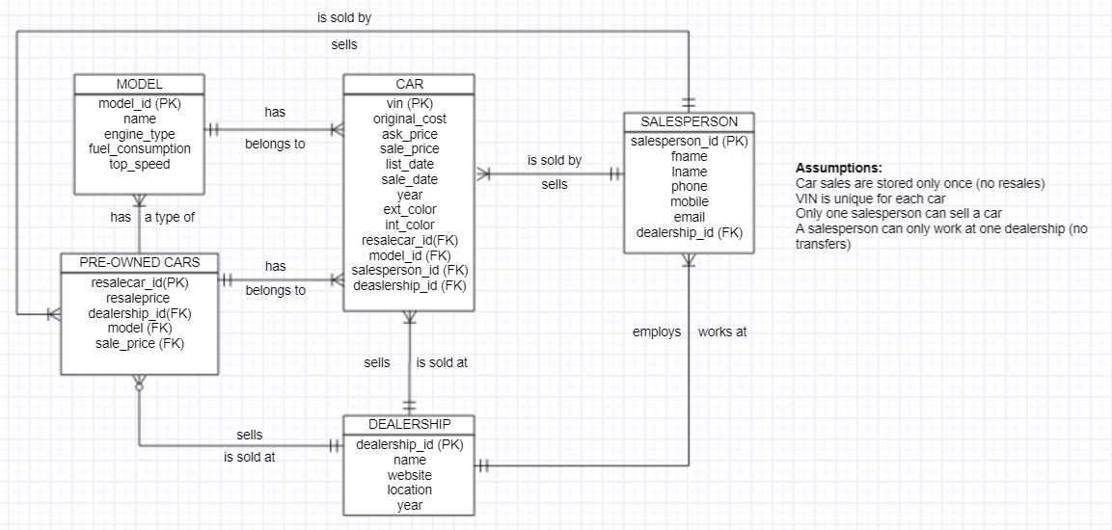

b. Some additional analysis that we can do given this new information is:

* What is the difference between the original price and the sales price? This would be the true indicator of loss/gain that the dealership has.
* How different are the original prices to the ask price? This would be a big indication of potential profit that each dealership could be making or an indication of how well they are doing.
* How different are the sale prices to the re-sale prices? This would just be a good indicator for if the dealership is making profit selling the older cars.

c. SELECT ROUND(AVG(CAR.original_price - CAR.sale_price))

FROM CAR

ORDER BY AVG(CAR.original_price - CAR.sale_price)